PSU ECE Capstone Team 04 Contract

# Contact Information

## Team Members

| **Team Member Name** | **Phone** | **Email** |
| --- | --- | --- |
| Henry Sanders**\*** | (831)430-6299 | [hensan@pdx.edu](mailto:hensan@pdx.edu); [henry.sanders@pgn.com](mailto:henry.sanders@pgn.com) |
| Chris Kane-Pardy**\*** | (707)708-1761 | [chrisk@pdx.edu](mailto:chrisk@pdx.edu); chris.kane-pardy@pge.com |
| Wallace McKenzie | (503) 816-2963 | [mwallace@pdx.edu](mailto:mwallace@pdx.edu); [wallace.w.mckenzie@intel.com](mailto:wallace.w.mckenzie@intel.com) |
| Kamal Smith | (971)706-3078 | kamal@pdx.edu |

## Industry sponsor

| **Organization and Name** | **Phone** | **Email** |
| --- | --- | --- |
| COATL - Josh Mendez |  | joshmen@pdx.edu |

## Faculty Advisor

| **Name** | **Phone** | **Email** |
| --- | --- | --- |
| Dr. Mark Martin |  | marmart2@pdx.edu |

# Project Objective

We would like to complete the project as defined by our industry sponsor, fully meet the rubric requirements as defined by our faculty advisor, have fun, and ideally end up with a patent at the end of it.

# Member Skills, Strengths, and Areas of Practice

| **Teammate Name** | **Key areas of strength to leverage in the project** | **Key areas of practice and development in the project** |
| --- | --- | --- |
| Henry Sanders | -LTSpice, KiCAD, Altium  -Python, C, Assembly  -Leadership  -Organization/Documentation/making things pretty  -Technical Communication/Writing  -Soldering  -PCB/Circuit Design  -Software/Hardware Debugging  -Oscope/DMM/VNA, etc.  -Power Systems | -Machine learning  -3D Modeling/Printing |
| Chris Kane-Pardy | -Measurement & Test Equipment Operation (Oscilloscope, DMM, VNA, etc.)  -Hardware Debugging  -Software/Code Debugging  -Hardware Architecture Design  -Python, C, Assembly Language  -Emag/RF Design  -Microelectronic Circuit Design  -Leadership  -Memory Architecture/Hierarchy & Optimization  -Soldering  -PCB/Circuit Design  -Microcontrollers  -3D Modeling  -RISC-V  -Organization/Documentation/making things pretty | -Machine Learning |
| Wallace McKenzie | -C,C++,Python,Assembly,drivers, MATLAB  -Soldering  -Oscope,DMM,VM,Current Meter -LTSpice  -Embedded Systems, Microcontrollers, ESP-IDF  -Leadership, project tracking, project management  -Documentation, White Papers, Package development (for systems, specification, and training)  -Training Coordination -Mentorship -Hardware emulation (Learned in ECE 485/486)  -Software and Code troubleshooting and debugging  -Memory (technology, optimization, and developed hierarchy)  -Microprocessor design and development (both emulation and process development)  -Applied Optics (lasers and electron microscopes) | -Machine Learning  -3D Modeling/Printing  -PCB Design |
| Kamal Smith | -Code Debugging  -Hardware design  -C  -PCB Circuit Design  -Microcontrollers  -3D printing | -Machine Learning |

# Meetings

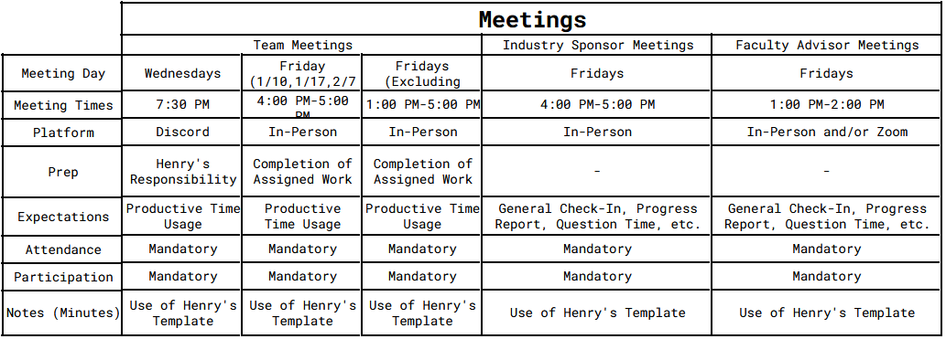

# Communications

## Preferred Method of Communication

* Discord for general communication and updates between team members and industry sponsor
* Email for faculty advisor

## Information Architecture

* GitHub
* Google Drive

# Team Working Agreements and Expectations

## Guiding principles of how we work together

Division of work should be equal, and progress made should be well communicated.

## How we make decisions

Group consensus.

## Approach to Conflict

If a conflict arises, whether it is productive or interpersonal, we expect that the person feeling conflicted will communicate their feelings/ideas such that a constructive dialogue can be entered into and the conflict be resolved.

## Project Standards

The main objective for this project and team is to 1) Put maximum effort into the overall project quality and design. Quality is not only our #1 goal, it is essential in the final design and functionality of the project. 2) Given that we are working with 60GHz mm waves, showcasing the functionality of how the product design works, along with why and what makes it work, effectively, is key to the success of, and for this team and project. 3) Grade expectations are to achieve academic excellence, and meet our goals and objectives.

## How we will hold each other accountable

If for any reason any group member is unable to complete an assigned task by a deadline, the expectation is that the group member will communicate this to the group in advance to the best of their ability. Also, if for any reason a group member is consistently late to meetings, late on deadlines, not communicating, generally slacking, etc., it is the responsibility of all other group members to check in with them, provide constructive feedback, and attempt to help them get back on track. If issues are persistent i.e. continuing after multiple attempts to resolve the issue, it is the responsibility of all other group members to notify the Capstone Coordinator.

## How we will give and receive feedback

The expectation for giving feedback to group members is to do so constructively, respectfully, and in a way that empowers them. We intend to heed the advice given in ECE 411 of not attaching our egos to this project - this way, we can cultivate a positive learning environment where all group members feel safe to both give and receive feedback.

## Team Contract Signatures

*By typing in your name, you agree:*

1. *I participated in formulating the standards, roles, and procedures as stated in this contract.*
2. *I understand that I am obligated to abide by these terms and conditions.*
3. *I understand that if I do not abide by these terms and conditions, I will suffer the consequences as stated in this contract.*

| **Team Member Name** |
| --- |
| [Henry Sanders](mailto:hensan@pdx.edu) |
| [Wallace McKenzie](mailto:mwallace@pdx.edu) |
| Kamal Smith |
| (Chris Kane-Pardy) |